ARL Webinar Proposal & Guidelines & Post Webinar Promotional Summary

Company Name:
Webinar Title:
Webinar Preferred Date: - All UK Webinars to be held on a Tuesday at 10am unless otherwise agreed:
Speaker Name(s) & Contact Info:
Event Description and Agenda: Please do not exceed 300 words. It cannot be a sales piece; it must be educational and informative:
Learning Outcomes: include relevance to BTR
Point of contact:
Name
Email |  | Telephone No.

Speaker & Panellist Details profile (Please include ALL persons that require logistical notifications/including in promotional content that are attending this Webinar)

Name
Email |  | Telephone No.

Name
Email |  | Telephone No.

Picture(s) and Bio(s) for ALL Speaker and Panellists:

Do you require ARL CEO to introduce the session? ☐Yes/☐No
Do you require ARL CEO to moderate the Q&A? ☐Yes/☐No
Please confirm that you will provide a marketing image to be used in the invitation email? ☐Yes/☐No
Please confirm that you will provide up to 700 word write up and photos of the event? ☐Yes/☐No
Special Requirements: Is there anything else we need to be aware of?

Webinar Guidance:
- Objectives / Key points:
  - Webinars should be positioned as Continuing Professional Development (CPD) opportunities are should therefore educational – intended to enable members (and occasionally non-members) to share experiences and learn from the subject matter expert(s).
  - Webinars are not marketing events – the event should not sell or promote a particular product or service.
  - A panel/roundtable format tends to be the most popular and effective approach with a cross section of industry panellists representing different sectors of the market. Please note that ARL is committed to supporting a diverse and inclusive real estate sector and with that in mind request that all panels are not homogenous and are gender balanced and diverse in terms of ethnicity, geographic representation and, where appropriate, seniority.
  - The audience could come from all sections of the ARL (i.e. investors, operators, agents, advisors and suppliers) with varying levels of seniority.
  - Experts and attendees should be aware of competition law and anti-competitive discussion should avoided – advice can be provided where appropriate.

- Format
  - Timings – event goes live at 10am-11am – 40 minute expert presentation / opening talk followed by 20 minute Q&A / Debate - Audience moderated by CEO or Chair.
  - Introductions – Expert and topics and any other general observations – CEO or Chair.
  - Closing remarks / thanks – CEO or Chair / Host.
  - Write up published on ARL website (600 words) and by host within 3 days after the event (unless held under Chatham House rules).

- What works well
  - Prompt start and finish time.
  - An open discussion for sharing and efficient technology.
  - An interesting topic – well marketed by the ARL so that we get a good attendance – target 40 - 50 attendees.
  - A challenging and knowledgeable presentation / opening talk with evidence-based conclusions / insights (Speakers should assume that attendees understand BTR but may not understand the background to the specific topic).
  - Enthusiasm and energy from the speakers, engagement by and relevance to the audience.
  - Lots of questions from attendees.
  - Having back up questions prepared.
  - Attendees come away feeling they have learnt a lot – from the speakers and from each other – genuine sharing of knowledge and connection.

- Process and Responsibilities

Process step | Who | Notes
- Propose topic for roundtable | Anyone (Proposer)  Proposer assumed to be person wanting to lead the webinar. | Please discuss with ARL if uncertain (Emma Henderson)
- Approve topic in principle | ARL (or ARL committee)
- Complete this form | Proposer | ARL will provide guidance
- Approve form | ARL – CEO or committee
- Arrange date | Proposer & ARL & Host (if third party venue) | Date is usually dependent on ARL events programme and to fit with other industry & ARL events
- Create Zoom event | ARL | ARL will manage administration using Zoom
- Invitation list building | Proposer & ARL & Host | Webinars are open to all ARL members on principle. Proposer & Host can issue their own invitations as well
- Create / Approve Event invitation | ARL / Proposer | ARL will manage administration using ARL systems
- Marketing | ARL | ARL will market on ARL website, in News Buzz newsletter, social media and BTR News. Proposer & Host may also market as required
- Event recording / write-up | Proposer | Social media as required, Proposer to provide up to 700 word write up and photographs
- Follow up / Quality Assessment | ARL | - Survey issued to all attendees  - Write up / photos posted by ARL on website  - Non-members contacted by ARL  - Repeat dates booked

There is no cost from the ARL for organising a webinar.
Webinars are currently free to attend for delegates.
Due to GDPR ARL are unable to provide personal contact information for Registrants / Attendees. Names and Company names will be provided by way of a report before and after the event.

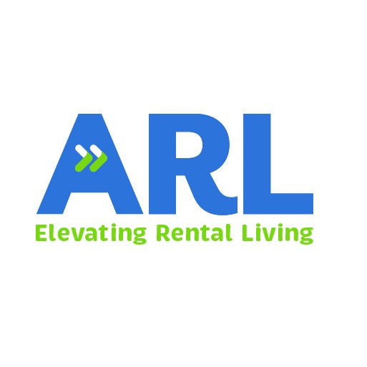

Post - Webinar Summary

- Please provide a summary of the webinar to be used on the ARL website and social media
- Please include:
  - the scope of discussion highlighting key insights, important messages or key points if possible, identify risks/problems that are reduced or solved by using/doing what is proposed in the webinar
  - a ‘Contact Us’ and logos etc.
  - Panellists
- Please do not exceed 700 words. It cannot be a sales piece; it must be educational and informative.

Webinar Name
Speaker(s)
Write up content to be published on ARL website

